Design Principle Sheet #1

Orientation

Orientation can be used to relate to the viewer a certain point of view through a certain perspective of any design, piece of art, or photograph. Depending on how the image is presented, is how the viewer can get a different idea or perspective from it. You may look at a photograph of an old war general from a WWII picture to see them standing upright, well composed, and in the center of the picture. This gives the viewer a sense of dignity, power, and exactness. This is a very traditional, conventional way of orientation.

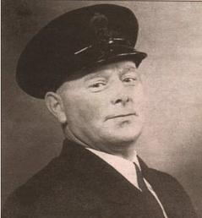

However, there is a more non-traditional way of orientation that I believe gives off a more artistic flare compared to our war general here that has taken a more prominent hold in recent modern times. This type of orientation can show the subject from a different angle or looking off in a different direction to direct the viewer’s attention to different parts of the image, or have them see something in a new kind of light.

[](http://farm4.static.flickr.com/3191/2570530201_6eb623d8ec.jpg?v=0)

The picture of this lady draws the eye off the page. The viewer is left wondering what she is looking at.

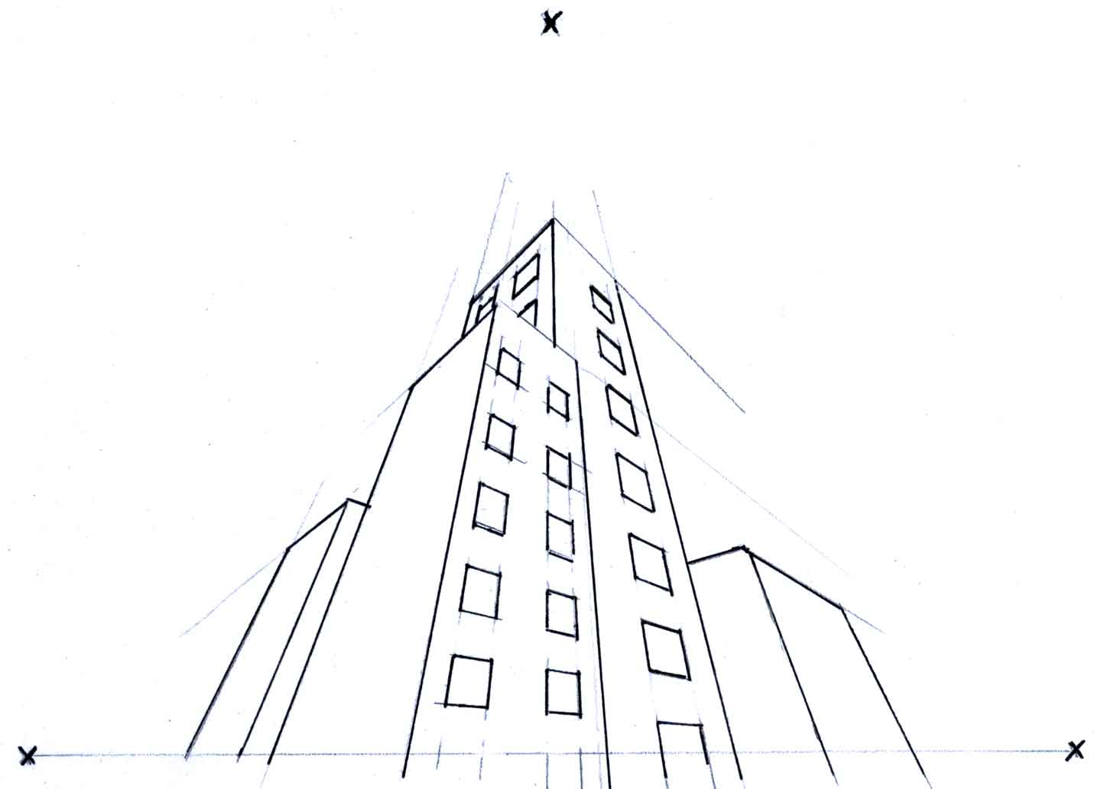

This line art draws the eye upwards towards the tops of the buildings.

Design Principle Sheet #2

Color

Color plays a prominent role in our daily lives. Each color has a different meaning that can instill different emotions and thoughts in our minds. Color is used to draw our attention to certain things. Green is calming and healing, red is loud and hard to miss, blue is quiet and easy on the eyes, etc..

Imagine if you saw a green STOP sign. It does not instill the same sense of warning or urgency as a red sign. This counts towards the orange CAUTION cones as well; orange is a very bright and obvious color that draws attention to itself so that the drivers are made aware of any kind of construction zones or restricted areas that they need to avoid.



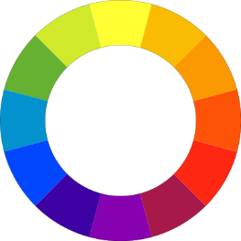

Colors are split into two categories of warm and cool. Warm consists of colors such as red, orange, and yellow, while cool colors include green, blue, and purple.

Primary colors include red, yellow, and blue.

Secondary colors are orange, green, and purple.

Tertiary colors: yellow-orange, yellow-green, blue-green, blue-purple, red-purple, red-orange.

Monochromatic color uses different variations of lightness and saturation for any particular color, such as the blue and red bar examples below.

 

An analogous color scheme includes colors that are adjacent to each other. The blues and purples are very close in proximity on the color wheel.



Complementary colors are opposite of each other on the color wheel.



Other color schemes include Split Complementary and Triadic.

 

Design Principle Sheet #3

Golden Ratio

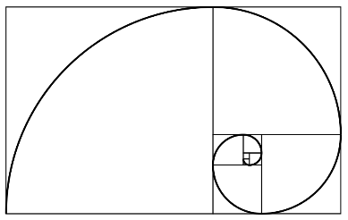

The Golden Ratio, also known as the golden section or the golden mean has been used by artists, architects, designers, etc.. It has been found to appear in patterns of nature. Researchers have found it in the veins of leaves, stems of plants, geometry in crystals, making many to believe that it is some form of universal law.

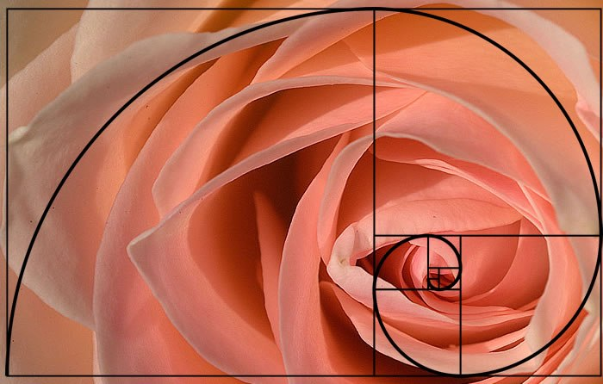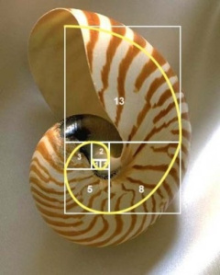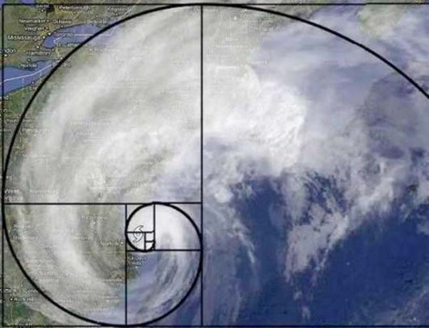

It has been applied in architecture.

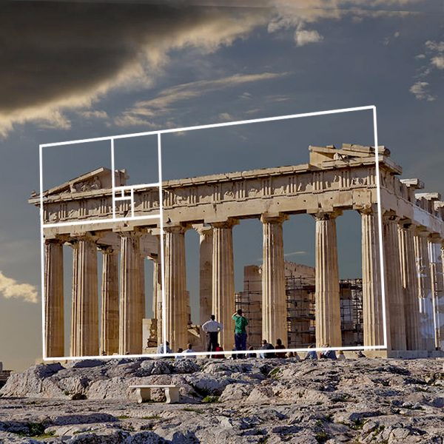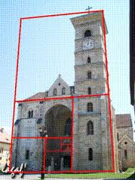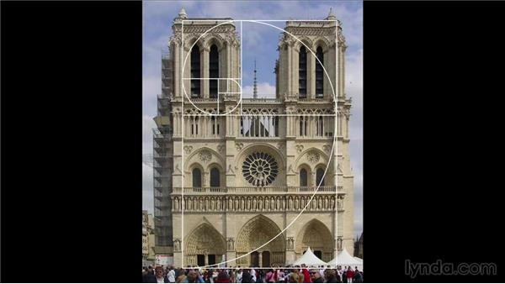

And art.

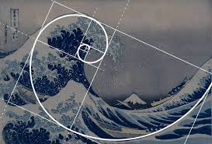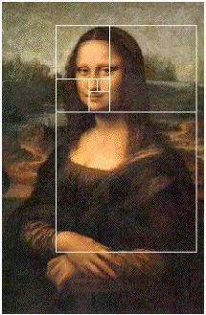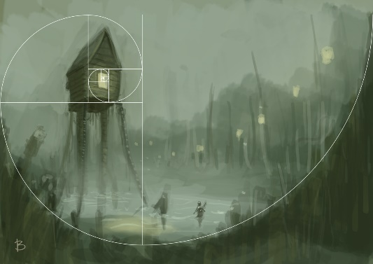

Design Principle Sheet #4

Interference Effects

Interference Effects occur when two or more perceptions are visually fighting against each other; causing the mental process of the viewer to slow down to try to make sense of things. The brain has to focus on the individual aspects of the piece in order to make sense of it as a whole. When they’re congruent, they’re easier to process than if they were incongruent, which takes more time for the viewer to take it all in.

[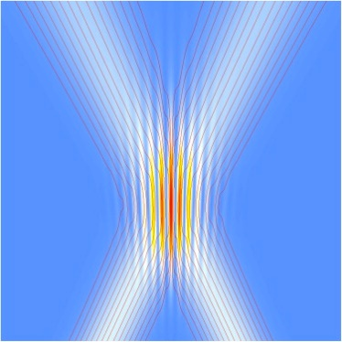](https://www.doctordisruption.com/wp-content/uploads/2012/11/1-s2.0-S0003491611001837-gr1.jpg)

If you read these words aloud, its much easier than saying aloud what color they actually are. It takes practice to do effectively.

[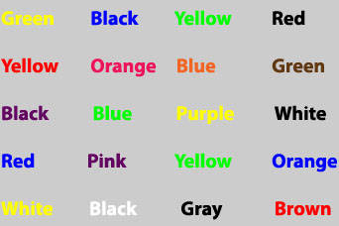](https://www.doctordisruption.com/wp-content/uploads/2012/11/stroop-effect.jpg)

Then there is Stroop Interference where an aspect of a mental process that interferes with something that has already been established. We’ve all been raised that Green means GO and Red means STOP, but look what happens when they’re switched. It doesn’t make sense, and becomes confusing to the viewer.

[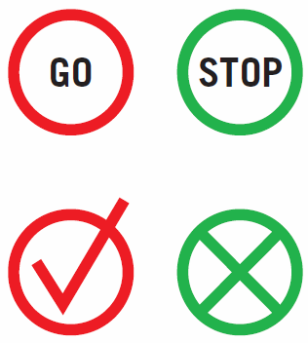](https://www.doctordisruption.com/wp-content/uploads/2012/11/1.gif)

When designers are coming up with new images and logos, they should take care to avoid interference effects so that their designs will become appealing to the eye, and not cause discomfort or confusion. Unless they’re intentionally trying to throw off their viewers that is.

Design Principle Sheet #5

Alignment

When text and other elements of design are lined up, that known as alignment. It helps to give off a sense of order, organization, and can create visual connections between different aspects of a design by making it readable.

There are different types of alignment that are used in various situations depending on how the design is put together.

Horizontal, where the text is lined up with both the left and right margins of a page, so that a white space is seen on both sides of the page. Sandwiching the text between them.

**[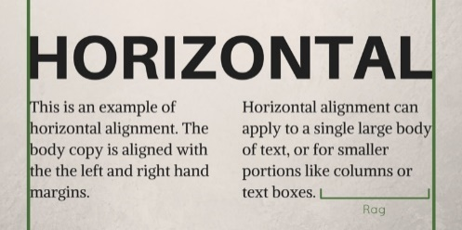](https://blog.thepapermillstore.com/wp-content/uploads/2015/06/Horizontal-Alignment.jpg)**

Vertical alignment centers the text at the middle point of the page and is lined up with the top and bottom margins of the page.

**[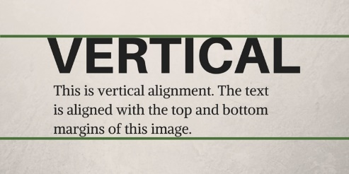](https://blog.thepapermillstore.com/wp-content/uploads/2015/06/Vertical-Alignment.jpg)**

Edge alignment is when design elements and text are lined up with tip, bottom, or side edges.

**[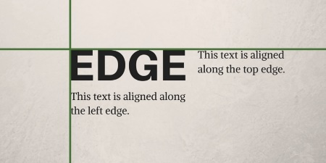](https://blog.thepapermillstore.com/wp-content/uploads/2015/06/Edge-Alignment.jpg)**

Center alignment centers the text along a middle axis.

**[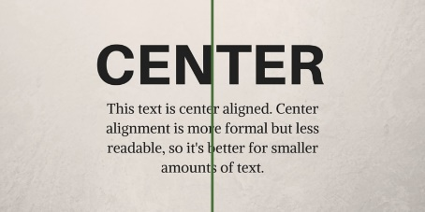](https://blog.thepapermillstore.com/wp-content/uploads/2015/06/Center-Alignment.jpg)**

If design elements are not properly aligned with added text elements, the project can look unprofessional and unpolished. Properly aligned designs and text can help create a good focal point and creativity. It all hinges on what you wish to relay to your viewers.

Design Principle Sheet #6

Propositional Density

Propositional Density is all about how a particular element of a design is received by the viewer. It gives information of what that design stands for through its look. It conveys a message to the viewer so that they know exactly what that logo or design represents. Take the FedEx logo for example. The colors of purple and orange go well together because being secondary colors they work. Purple has always been viewed as a color that represents people of great importance, in this case, the customers or the people receiving/sending the packages. There is a hidden arrow between the E and the X, giving a sense of efficiency to the viewer.

[](https://www.doctordisruption.com/wp-content/uploads/2015/12/fedex_logo.jpg)

In regards to the Apple logo, it is simple design, with clean, precise lines that give off a sense of high quality. It is a logo that can be easily recognized worldwide, and is associated with high-end technology, from state-of-the-art computer software, to phones, and other electronic devices like tablets. An apple is often associated with learning and wisdom, like Sir Isaac Newton’s discovery of gravity. And how many times do we see an apple being a primary gift to a well-beloved teacher?

[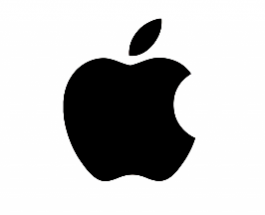](https://www.doctordisruption.com/wp-content/uploads/2015/12/Official_Apple_Logo_2013_Pictures_5_HD_Wallpapers.png)

Great consideration should be taken when using propositional density to design a logo. It needs to be engaging and memorable, and catch the interest of the viewer and target audiences. The more thought and care put into really digging down to the core of each design will help it become that much more iconic. Think of the Disney logo. A simple word adapted from Walt Disney’s own signature. Disney has become a household name for every child born within the last century, and is an entertainment giant in today’s media world.

